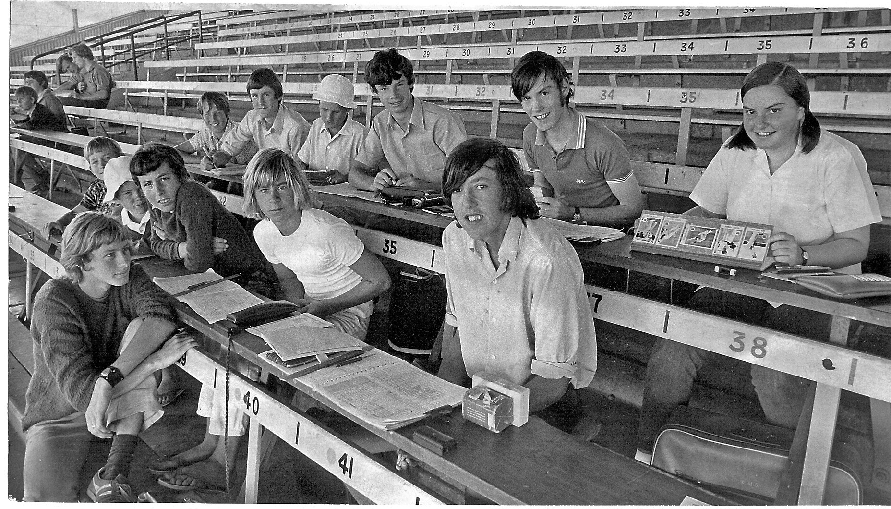

**Young scorers ready for the days play Lancaster Park 1971 Karen Feely Back row Far right**